# INSIGHT STREAM: NAVIGATE THE NEWS

**Introduction**

## Project Title

Insight Stream – A real-time data streaming and analytics platform designed to provide businesses, researchers, and developers with live insights from various data sources.

|  |  |
| --- | --- |
| **Team ID** | **NM2025TMID35241** |
| **Team size** | **4** |
| **Team Leader** | **SWETHA K** |
| **Team member** | **THARANIKA B** |
| **Team member** | **THILAGAVATHI A** |
| **Team member** | **MUKILVANI T** |

## PROJECT OVERVIEW

**Purpose**

The Insight Stream project aims to offer a seamless, real-time data streaming and visualization platform. The goal is to allow users to monitor, process, and analyze live data feeds in an interactive and efficient manner.

## Features

Real-time Data Streaming: Processes data from various sources (IoT, APIs, Databases, etc.) in real time.

Interactive Dashboard: Visual representation of live data through charts, graphs, and tables.

Custom Filters & Alerts: Users can filter data based on parameters and set alerts for anomalies.

Secure Data Handling: Implements encryption & authentication mechanisms to protect data. Integration with APIs: Supports external APIs for fetching data from multiple platforms.

# ARCHITECTURE

## Component Structure

The application follows a modular architecture, consisting of the following components:

* Data Ingestion Layer: Connects to data sources such as APIs, databases, and IoT devices.
* Processing Unit: Handles real-time data transformation and filtering.
* Visualization Module: Displays insights using graphs, tables, and reports.
* User Interface (UI): A React-based interactive UI for users to interact with data.

# STATE MANAGEMENT

Global State: Managed using Redux or Context API to share data across components. Local State: Managed within individual React components for UI responsiveness.

## Routing

* Uses React Router for navigation.
* Key routes include:

**Dashboard:** Main analytics view **Settings:** User settings and configurations **Reports:** Historical data reports

## SETUP INSTRUCTIONS Prerequisites

Before setting up the project, ensure that you have installed:

* Node.js (for running the frontend)
* Python (if backend is built with Flask) or Node.js (Express.js)
* Database (MySQL, PostgreSQL, or MongoDB)
* Git (for version control)

# INSTALLATION

Follow these steps to set up the project locally:

## Clone the Repository:

git clone https://github.com/PK5674/InsightStream-Navigate- the-News-Landscape insight-stream

## Install Dependencies:

npm install # Installs frontend dependencies

pip install -r requirements.txt # Installs backend dependencies (if using Python)

## Set Up Environment Variables:

Create a .env file and add database/API keys.

## Run the Application:

npm start # Starts frontend python main.py # Starts backend (if using Python)

# FOLDER STRUCTURE

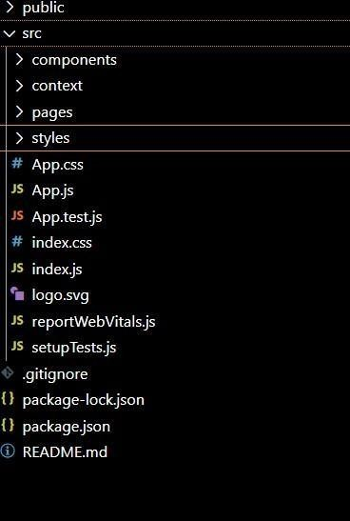

**CLIENT (FRONTEND) STRUCTURE :**

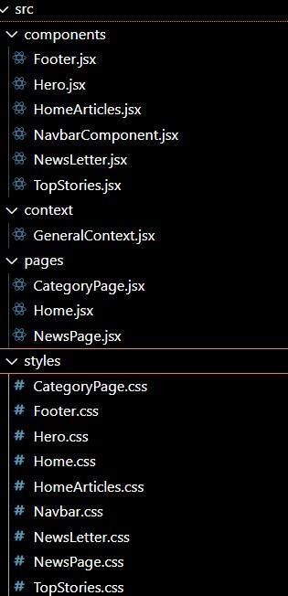

# RUNNING THE APPLICATION

## To start the frontend:

npm start

## To start the backend (if using Python Flask):

python main.py

## To start the backend (if using Node.js):

node server.js

# COMPONENT DOCUMENTATION

The Insight Stream frontend is built using React, with a modular component-based architecture. Each component serves a specific purpose, ensuring reusability, maintainability, and scalability.

### Layout Components

These components define the overall structure of the application, including navigation, headers, and page layouts.

* 1. Navbar (components/Navbar.js)

Purpose: Displays the top navigation bar with branding, user profile, and quick actions. Props:

user (Object) – User details for displaying profile picture and name. onLogout (Function) – Triggers the logout function.

Features:

Adaptive UI (hides certain elements on mobile screens). Theme toggling (dark/light mode).

* 1. Sidebar (components/Sidebar.js)

Purpose: Provides a collapsible sidebar with navigation links. Props:

menuItems (Array) – List of navigation options. isOpen (Boolean) – Controls sidebar visibility.

Features:

Dynamic menu rendering.

Role-based navigation (admins see additional options).

* 1. Footer (components/Footer.js)

Purpose: Displays copyright information and links. Props: None.

Features:

Auto-updates the current year dynamically. Responsive design.

### Dashboard Components

The core UI elements that present real-time data and analytics.

* 1. Dashboard Overview (features/dashboard/Dashboard.js)

Purpose: Serves as the main dashboard view displaying widgets, charts, and key metrics. Props: None (fetches data internally).

Features:

Fetches real-time analytics.

Displays summary widgets for user engagement, trends, and alerts.

* 1. Analytics Card (components/AnalyticsCard.js)

Purpose: Renders small data insights within the dashboard. Props:

ttle (String) – Card title.

value (Number) – Numerical representation of the metric. icon (JSX) – Icon representing the metric.

Features:

Animated number counting.

Configurable styles for different data types.

* 1. Chart Component (components/Chart.js)

Purpose: Displays dynamic charts using Chart.js or Recharts. Props:

data (Array) – Data points for the chart.

type (String) – Chart type (e.g., "bar", "line", "pie"). Features:

Supports multiple chart types. Real-time data updates.

### Authentication Components

Handles user login, registration, and authentication.

* 1. Login Form (features/auth/Login.js) Purpose: Provides user login functionality. Props: None.

Features:

Input validation.

Secure authentication with JWT. Error handling for invalid credentials.

* 1. Registration Form (features/auth/Register.js) Purpose: Allows new users to create an account. Props: None.

Features:

Field validation (email format, password strength). Password hashing before sending to backend.

* 1. Logout Button (components/LogoutButton.js) Purpose: Logs out the user and clears session data. Props:

onLogout (Function) – Handles logout process. Features:

Redirects user to the login page upon logout.

### User Profile Components

Manages user account settings and personal data.

* 1. User Profile Card (features/user/ProfileCard.js)

Purpose: Displays user details, including name, email, and profile picture. Props:

user (Object) – User information. Features:

Editable fields for updating profile details.

* 1. User Settings Panel (features/user/Settings.js)

Purpose: Allows users to modify app preferences (e.g., theme, notifications). Props: None.

Features:

Supports real-time settings updates. Dark/light mode switching.

1. Notification & Alerts Components

Manages system alerts and notifications.

* 1. Notification Bell (components/NotificationBell.js) Purpose: Displays new alerts and notifications.

Props:

count (Number) – Number of unread notifications. Features:

Real-time push notifications. Dropdown for viewing messages.

* 1. Toast Notifications (components/Toast.js)

Purpose: Displays success, error, and warning messages. Props:

message (String) – Text to display.

type (String) – Defines message type (success, error, warning). Features:

Auto-dismiss functionality. Customizable duration.

### Utility Components

Reusable components that enhance functionality across the app.

* 1. Button Component (components/Button.js)

Purpose: Reusable button component with dynamic styling. Props:

text (String) – Button label.

onClick (Function) – Click event handler.

variant (String) – Type of button (primary, secondary, danger). Features:

Adaptive styles based on variant.

* 1. Modal Component (components/Modal.js)

Purpose: Renders popup dialogs for confirmation messages or forms. Props:

title (String) – Modal header text.

isOpen (Boolean) – Controls visibility.

onClose (Function) – Function to close modal. Features:

Supports draggable and resizable modals.

* 1. Spinner Component (components/Spinner.js)

Purpose: Displays a loading animation during API calls. Props: None.

Features:

Customizable size and speed.

# STATE MANAGEMENT

Managing state efficiently is crucial for ensuring seamless user interactions and optimal performance. Insight Stream employs both global and local state management strategies.

### Global State Management

Redux Toolkit is used for managing the global state, ensuring smooth data flow across components.

The state is structured into slices, making data handling modular and efficient.

Middleware such as Redux Thunk is implemented for handling asynchronous API requests, ensuring real-time data updates.

Persistent state storage is handled using Redux Persist, which retains user preferences even after a page refresh.

### Local State Management

React’s useState Hook is used for managing UI-specific states, such as dropdown selections, modals, and toggles. useContext API is utilized for lightweight state sharing between components without unnecessary prop drilling.

### Performance Optimization

Memoization techniques like useMemo and useCallback are employed to prevent unnecessary re-renders.

Selective state updates ensure that only the necessary components re-render when the state changes.

# USER INTERFACE

The Insight Stream UI is designed for intuitive navigation, real-time interactivity, and customization.

### Key Features

Interactive Dashboards: Displays real-time data streams with dynamic updates.

Customizable Widgets: Users can modify and rearrange dashboard components to suit their needs.

Dark & Light Mode Support: Improves accessibility and reduces eye strain.

Responsive Design: Ensures a seamless experience across desktops, tablets, and mobile devices.

Tailwind CSS is used for styling, offering a clean and consistent UI with minimal CSS bloat.

SASS/SCSS Support allows for advanced styling features such as nested selectors and variables.

User Customization: Users can change themes, colors, and font sizes based on preferences.

### Navigation & Routing

React Router is used for seamless page navigation without full-page reloads.

Breadcrumb Navigation helps users keep track of their location within the platform.

## Styling

CSS Frameworks/Libraries

Uses Tailwind CSS for styling.

Supports SASS for advanced styling features.

## Theming

Users can customize themes and color palettes.

# TESTING

## Testing Strategy

A robust testing strategy ensures reliability, security, and performance. The Insight Stream platform follows a structured testing approach:

### Unit Testing

Jest & React Testing Library are used for testing individual components. Ensures each UI element and function performs as expected.

### Integration Testing

Verifies the interaction between the frontend, backend, and APIs.

Supertest (for Node.js) and pytest (for Python Flask) are used for validating API responses.

### End-to-End (E2E) Testing

Cypress is used to simulate real-world user interactions.

Tests are written to check login flows, data visualization, and user settings changes.

### Performance Testing

Lighthouse (Google Chrome DevTools) is used to evaluate page load speeds and UI responsiveness.

JMeter is used to analyze API response times and handle concurrent users.

### Security Testing

Regular vulnerability scans are performed using OWASP ZAP.

Data encryption and CSRF/XSS protection mechanisms are validated**.**

# SCREENSHOTS :

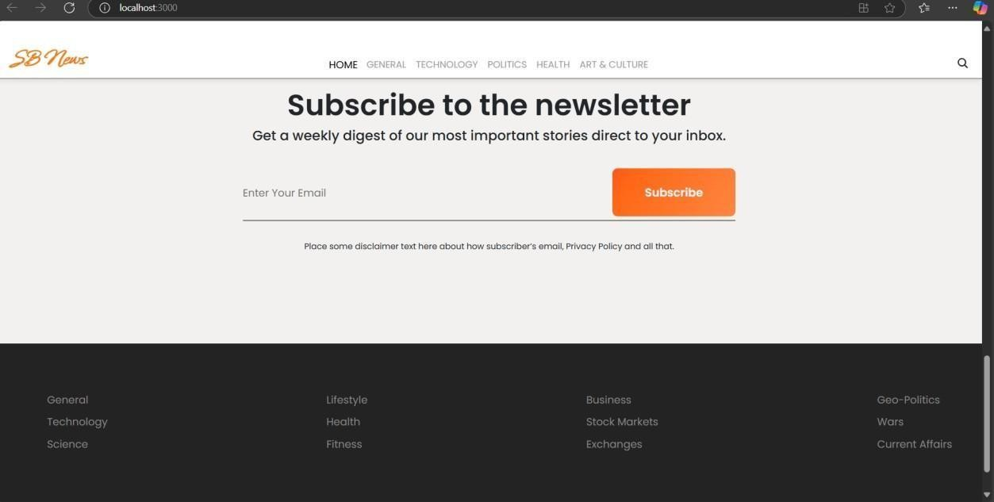

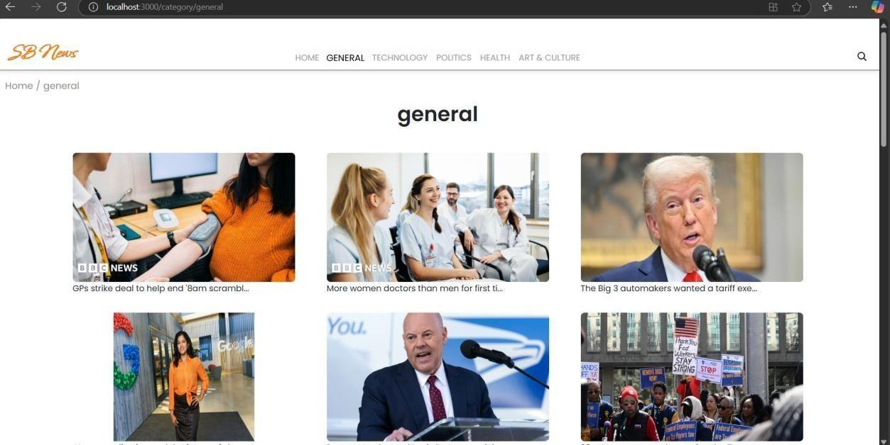

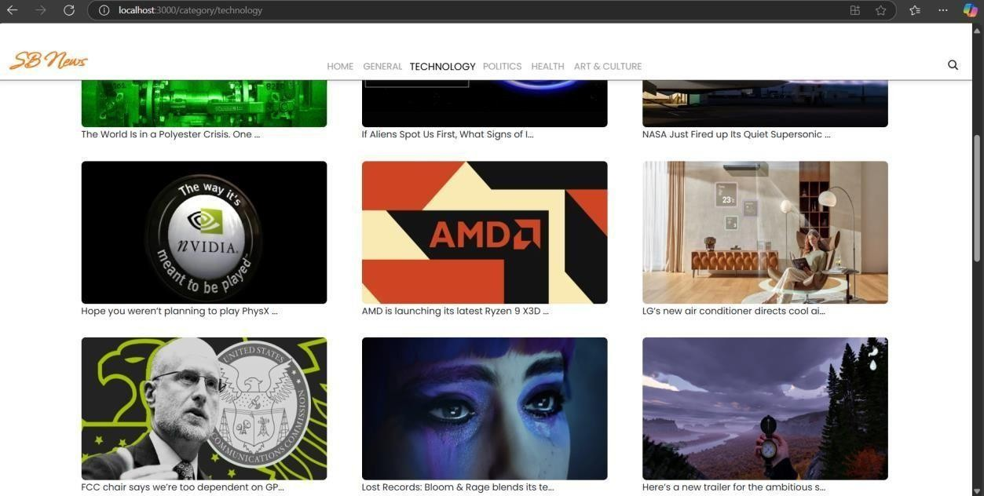

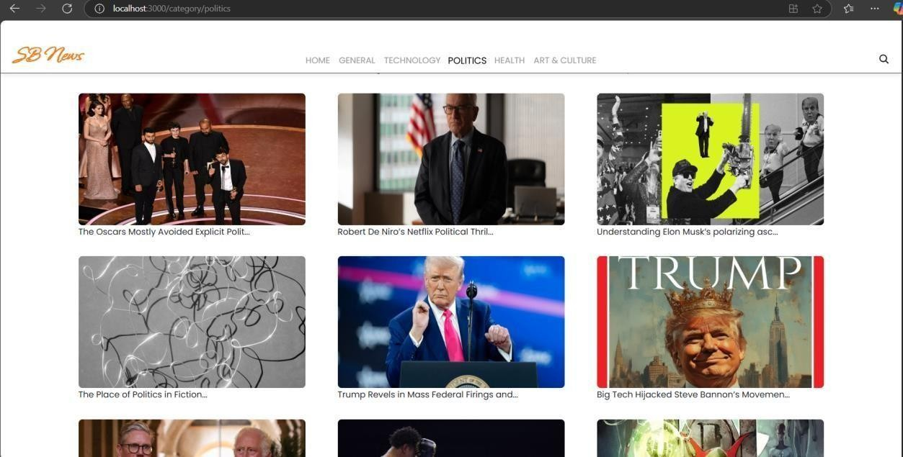

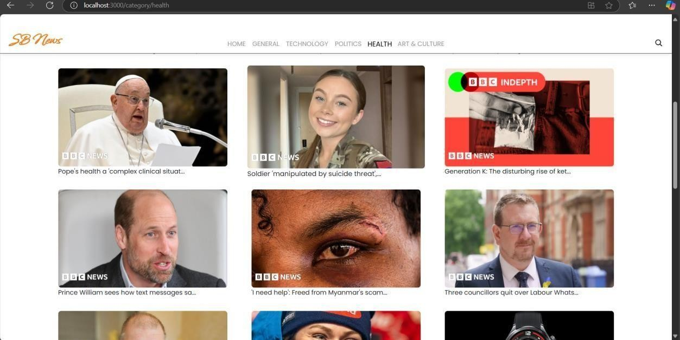

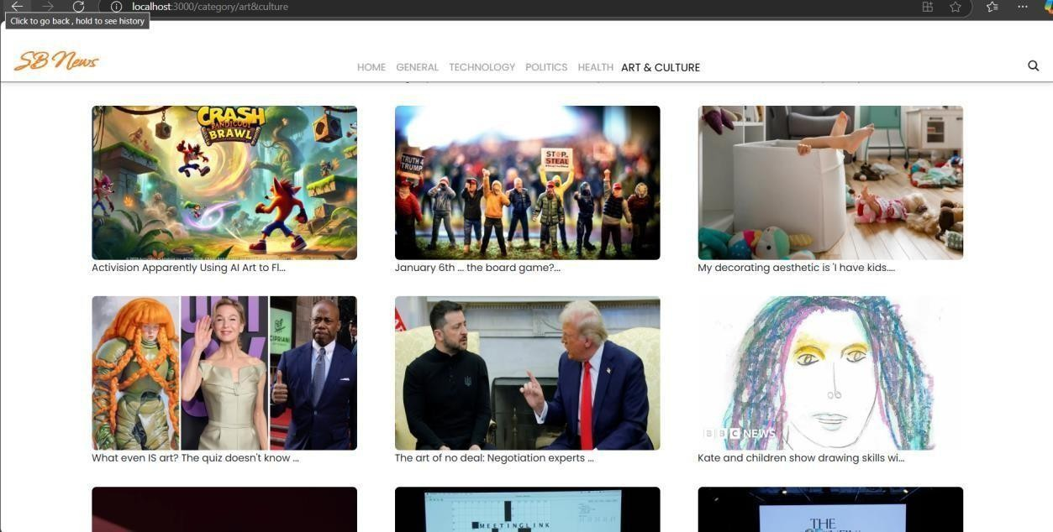

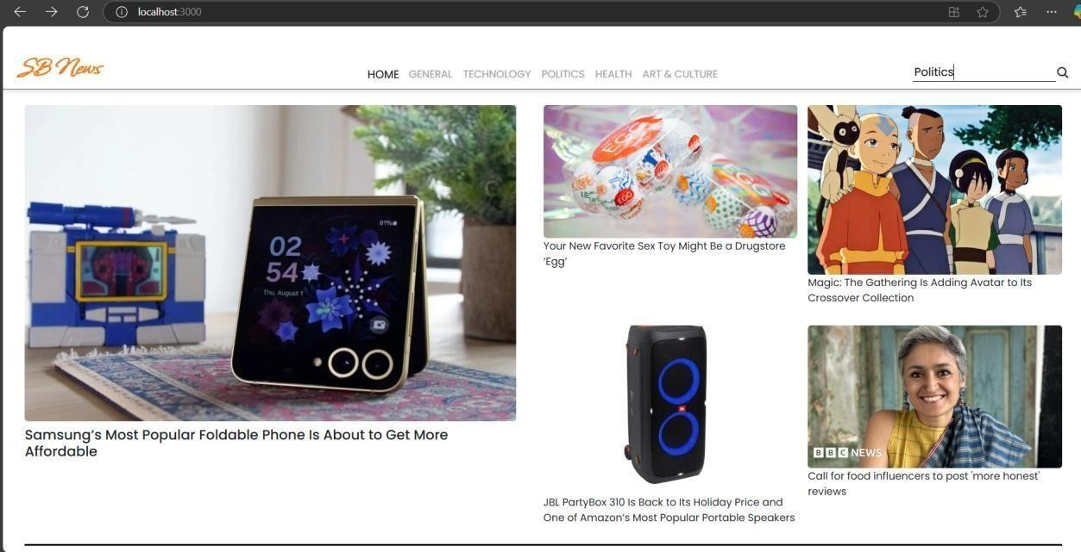

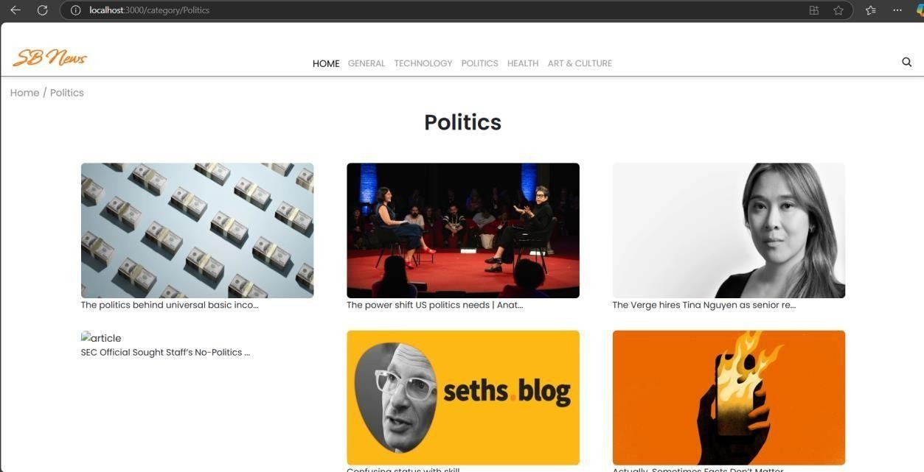

**KNOWN ISSUES**

While Insight Stream offers real-time data processing and analytics, certain challenges and limitations exist. These will be addressed in future updates.

### Data Latency

Issue: A slight delay in processing and displaying large datasets, particularly when handling multiple real-time streams.

Cause: Network latency, API rate limits, and backend processing overhead.

Possible Solution: Optimize data fetching using WebSockets instead of traditional HTTP polling and implement caching mechanisms to reduce response time.

### Browser Compatibility Issues

Issue: Some UI features may not render correctly on older browsers (e.g., Internet Explorer). Cause: Usage of modern JavaScript features (like ES6+ syntax) and CSS frameworks.

Possible Solution: Implement polyfills for backward compatibility and ensure extensive

crossbrowser testing.

### Memory Consumption & Performance Bottlenecks

Issue: High memory usage when handling extensive data visualization with large datasets. Cause: Heavy reliance on Chart.js and D3.js for complex visualizations.

Possible Solution: Optimize rendering with virtualization techniques and implement lazy

loading to reduce initial load time.

### API Rate Limits & Request Failures

Issue: If external APIs enforce rate limits, data fetching might be restricted. Cause: Too many concurrent API requests in short intervals.

Possible Solution: Implement API request throttling and retry mechanisms for handling failed

requests.

### Security Vulnerabilities

Issue: Potential risks of Cross-Site Scripting (XSS), Cross-Site Request Forgery (CSRF), and SQL Injection attacks.

Cause: User inputs and API interactions are not fully sanitized.

Possible Solution: Implement input validation, server-side security checks, and stricter authentication mechanisms (JWT, OAuth).

### Scaling Limitations

Issue: Performance degradation when multiple users access the platform simultaneously. Cause: Backend infrastructure may not be optimized for high concurrent requests.

Possible Solution: Implement load balancing, horizontal scaling, and migrate to a

microservices architecture if necessary.

### Lack of Offline Support

Issue: Users cannot access dashboards or analytics if they lose internet connectivity. Cause: No local storage caching or progressive web app (PWA) support.

Possible Solution: Implement IndexedDB/localStorage caching and explore PWA features for

offline capabilities.

# FUTURE ENHANCEMENTS

To enhance functionality and user experience, several advanced features are planned for future versions of Insight Stream:

### AI-Powered Insights

Implement machine learning algorithms to detect patterns and predict trends in data streams. Use Natural Language Processing (NLP) for data-driven decision-making.

### Voice Commands & Accessibility

Voice-enabled interactions allow users to issue commands hands-free. Screen reader support ensures accessibility for visually impaired users.

### Mobile App Integration

Develop a mobile application (React Native) for real-time data monitoring on smartphones. Enable push notifications for anomaly alerts and critical insights.

### Multi-User Collaboration

Introduce role-based access control (RBAC) to allow multiple users to work simultaneously.

Implement real-time collaboration features, such as shared dashboards and team-based analytics.

### Blockchain for Data Integrity

Use blockchain technology to ensure data authenticity and prevent unauthorized modifications.

Implement smart contracts for secure and transparent data transactions.